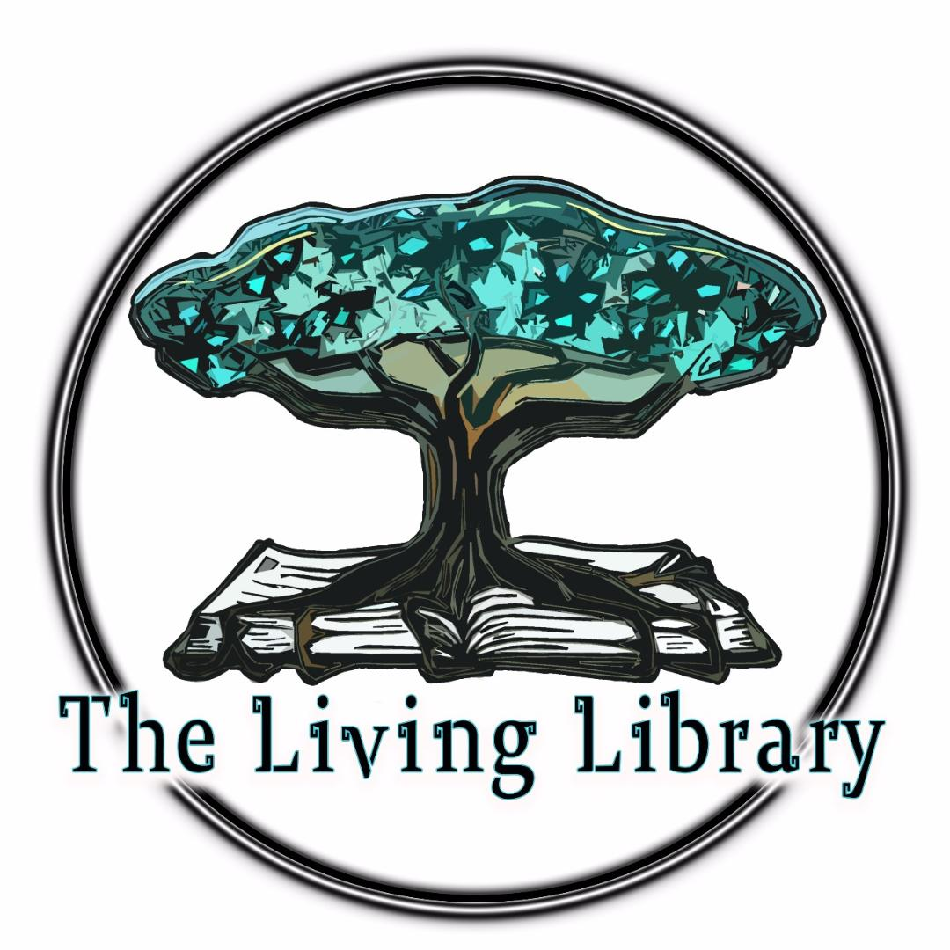

Sacred Hands 101
2026 edition

Dear one, as your journey has brought you to our beautiful community, we kindly ask you to go through this handbook designed specifically for Sacred Hands.
Welcome to Our Sacred Hands Program
We are thrilled to have you join us as a Sacred Hand ! Your role in caring for the main hall, cooking, and maintaining cleanliness is vital to the harmony and well-being of our community.
As a diverse group with unique backgrounds and perspectives, we believe in creating a shared foundation where kindness, respect, and mindfulness guide our actions. Your contributions will not only help maintain our physical spaces but also nurture the welcoming and inclusive spirit that defines us.
In this handbook, you’ll find clear guidelines to support you in your role. These are designed to ensure our community operates smoothly while respecting the diverse needs of all members. We encourage you to approach your tasks with love, devotion, and care, bringing your full self to every activity.
Thank you for choosing to share your time and energy with us. Your efforts make a meaningful difference, and we are deeply grateful to have you here. Welcome to the team !

Blessings,
the Living Library Community

Sacred Hands Position Guidelines: General maintenance, Main Hall management, Gardening, cleaning and cooking shift
As a Sacred Hands, your role is essential to maintaining the heart of our community. Through mindful tasking, cleaning, and organization, you will help create a welcoming and nourishing space for everyone. Your exchange for staying here is a 5-6 hour shift of working for the community and the land from Monday to Thursday. These guidelines will support you in fulfilling your responsibilities with care and excellence:

Main Hall and Common Areas
Maintain cleanliness: Keep all areas of the Main Hall, including tables, chairs, countertops and floors, clean and tidy.
Create a welcoming atmosphere: Arrange the space to be inviting and comfortable, encouraging people to gather and connect in the Main Hall.
Keep the cupboards and storage neat: Ensure cupboards, food storage areas, and the refrigerator are well-organized and cleaned regularly.
Bathrooms: Empty the toilet paper bucket and put a new bag, keep the toilet bowl and the sink clean regularly.
Outside sink: Anything that may clog the sink (coffee filters, sink filters, oil, seeds etc) must be washed in the outside sink,
Sunset club: People living on the deck upstairs (might be you) always welcome other residents to chill, share a community time while watching the sunset, playing music, meditate, do yoga and more. All we ask is to be respectful if they want a quiet moment, to give love to the space by sweeping it and keeping it clean and tidy and to be quiet after 9 pm and before 7 am.

Cooking and Meal Preparation
Cooking for lunch and dinner depends on the number of people and events on site. If there are more than 2 volunteers on site, cooking from monday to friday becomes a Sacred Hands task. Unless a professional cooker is in the place, a shift is done between all the residents. Otherwise, each person eats at their own pace, but we usually have some meals together and love to do community cooking.
Cook with intention: Prepare meals mindfully, using the ingredients with care to nourish the body, spirit, and mind of everyone in the community.
Be mindful of restrictions: Pay close attention to any food allergies or dietary restrictions to ensure meals are inclusive and enjoyable for all, those information are available on the white board. Make sure you cook for enough people, the number of residents may vary through the week.
Manage ingredients mindfully: Monitor food supplies, check expiration dates, and minimize waste by using ingredients efficiently and creatively. Once a week, (usually on wednesday), we go to la Feria (market) and to the grocery stores to get fresh food and restock what we need. When you finish something, put it on the grocery list. Don’t use community food to make personal snacks. Obviously don’t eat what is not yours, even if it doesn’t have a label on it.
Think about Pops: As you may know, Chris’s dad, Pops, lives with us. When we cook, we do a dish for him too. You are always welcome to have a cup of tea or a chess game in the afternoon with him.

Other tasks
Every day at the Living Library is different: Be open to taking on tasks beyond those guidelines, such as gardening, land care, or general maintenance. Flexibility is a major key when it comes to working with us.

General Expectations
Respect the space: Treat the kitchen, main hall, and all tools and equipment with care, returning items to their proper place after use. Your task is not over when the job is done, your task is over when the job is done, the area is clean and all the tools are properly stored in their proper space.
Foster community spirit: Approach your role with kindness, compassion, and a sense of devotion to the shared well-being of everyone in the community and the space.
What a regular day looks like
There isn’t a strict daily routine as everyday is different here, but we always guide you in planning your day effectively. We will help you identify and prioritize what matters most as it may vary day to day. Here’s an example of what a regular day could look like:
Starting your shift at 8 am
- Task given for the day (or next few days)
- Check on the white board for “Random things to do” if tasks are done;
- Go beyond =)
- Lunch must be served around 1:30 pm (if cooking shift is on);
- Dinner must be served around 7pm (if cooking shift is on) .

By following these guidelines, we help maintain a space where the community can thrive, the work you give is an optimum exchange for all parts, and your efforts create a foundation of nourishment and connection. Thank you for bringing your energy and care to this vital role! If you have any questions, inquiries or suggestions, our Teopalewe is at your service.

Thank you for taking the time to read this handbook and welcome to our beautiful community =)

The Living Library Community

